While Loop Quiz Name: Bibby

Given the ROBOTC code below, write the pseudo code that will describe what the program is executing. (13 points possible)

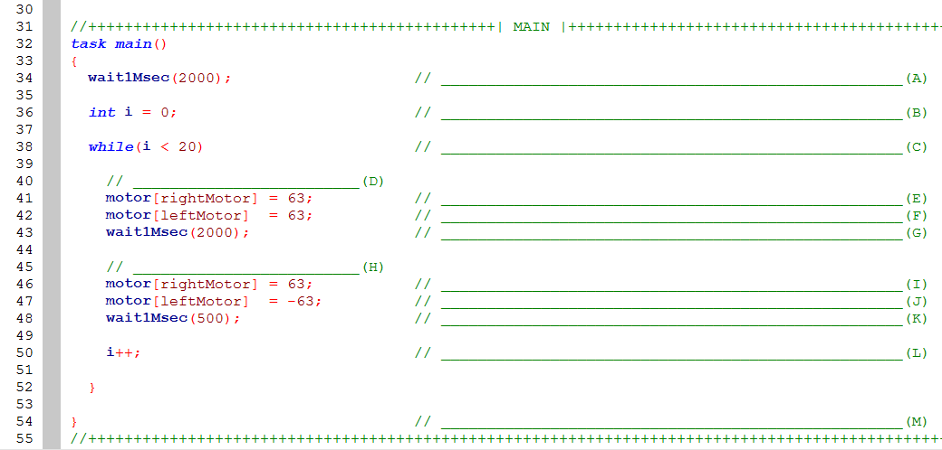

1. Wait 2 sec
2. Set i to 0
3. While i is less than 20
4. Drive forward at half power
5. Right motor half power
6. Left motor half power
7. Wait 2 sec
8. Turn left
9. Right motor half power
10. Left motor negative half power
11. Wait half second
12. Add 1 to i
13. Ending bracket

When would you use a program such as this? (7 points, complete sentences)

Make 5 squares